John Vos, James Shaw, Jack Whitchurch, Ross Jones

Abstract

Documentation of the process of building our VR escape room, such as; challenges, research, development, build levels, work done by which member

INTEGRATED GROUP PROJECT IN COMPUTING

Documentation

Table of Contents

Project Plan & Specifications: 3

Game Concept: 3

Teaching Concepts: 3

Contingency Plan: 3

Team Roles: 4

Ross 4

Jack: 4

James: 4

John: 4

Lesson plan: 5

Variables 5

Loops (iteration) 5

Sequence 5

Event handling 5

Testing: 5

Group Meeting: 5

Software being used: 5

Room Design: 6

Room 1: Variables 6

List of steps to complete the room: 6

Room Design: 6

Safe Design: 7

Room 2: Loops 8

List of steps to complete the room: 8

Room Design: 8

Maze Design: 9

Maze Solution: 9

Control Board: 10

Scratch Code Given: 10

Room 3: Sequence 11

List of steps to complete the room: 11

Room Design: 11

Room 4: Event Handling 12

List of steps to complete the room: 12

Room Design: 12

Research: 13

Room Design: 13

Coding: 13

Puzzles: 13

Clue: 13

Use Cases: 14

Use Case 1: 14

Use Case 2: 15

Use Case 3: 16

Use Case Modelling: 17

Time Frame: 18

Project Plan timeline: 18

Challenges: 19

Ross 19

Challenges encountered: 19

Jack: 19

Challenges encountered: 19

James: 19

Challenges encountered: 19

John: 19

Challenges encountered: 19

Evidence / Screenshots of Progress: 20

Original Pitch: 20

Game first design with textures: 21

Game stage 1: 22

Game interior: 24

Interaction with objects: 26

Blender: 27

References: 28

# Project Plan & Specifications:

## Game Concept:

The game will be a VR escape room aimed at KS3 (11 to 14 year olds) students studying computer science using unity (version 2018.3.6) for windows on the Vive VR set.

The player will have 1 hour to complete 4 puzzles to then create a piece of code that will unlock the door to the escape pod. Furthermore, they will have 8 minutes per room and if there is no progress within 3 minutes they will be given a hint to help to solve the problem.

We chose 1 hour as the game is in VR more than an hour in the headset can be too much and disorientate the player, research has also found that 2 hours is the absolute max. In addition, we chose 8 minutes per room as this will give the player enough time to then solve the final puzzle to get into the escape pod. The rooms can be done in any order though we will advise the user to complete them in order, each room will have a number above the door to indicate the order.

## Teaching Concepts:

We will be using scratch code blocks to teach key concepts of computer science coding. For the “assignment” version of the game we are focusing on building only 4 rooms due to the time constraint and skill level in regard to unity and VR. However, the full game would have a room to teach concept and a save / load function.

# Contingency Plan:

We are starting by making room 1 for VR, as none of us have any previous experience with Unity we are going to start with the first puzzle room to give an idea of the challenges and difficulty we are going to face during the development of this project. Furthermore, if this proves too much of a challenge for the time frame we have set and to be able to deliver a working VR escape room. Moreover, if the VR does prove to be too much of a challenge we are planning on falling back on simply making it a 2D escape room rather than 3D.

# Team Roles:

Ross:

3D assets & Room Design:

Responsible for creating 3D assets on Blender and assisting in designing the visual look of the game.

## Jack:

Programmer & sound effects:

Responsible for helping with programming and developing sound effects

## James:

Programmer;

Responsible for creating the scene in unity from a combination of 3D assets made by Ross and assets from the Assets Store

## John:

Admin & room design:

Responsible for writing documentation and designing the visual look of the game

## Lesson plan:

### 

### Variables

In scratch variables are taught in a block format that allows the user to create variables that can then be used in a program; instead of the user having to manually declare them. The variables include strings and numbers.

We will use this style of teaching variables to the users as it is clear and concise and an excellent visual way of representing something rather basic in terms of coding but a fundamental. Furthermore, as the target audience is 11 to 14-year olds with no previous knowledge of coding it is essential the information is absorbed.

### Loops (iteration)

In scratch there are only “forever” and “repeat” loops that can be used to iterate through the program. Therefore, we will use these to introduce the concept of how loops are used to run through a certain code (command) a set amount of times or till a task is complete.

### Sequence

A key concept of coding is that the code will run in a certain order and will execute in that certain task in that order. And without a strong foundation the person learning to code will be lost before they even begin.

### Event handling

In terms of coding this would be when the user is prompted to input something or interact with the code in some way. Scratch teaches this through prompts such as “when a key is pressed” or “when the sprite is clicked” and we will use this to teach the user about how events / code can be triggered through these when they are coded into a program. And will be used towards the final block of code used to unlock the door.

## Testing:

We will test the game ourselves as we develop each room, James’s cousin will also test the game as he is the target audience.

## Group Meeting:

We chose Wednesday as the due date for most of our deliverables as this is when we are always able to meet up every week. Furthermore, we will also communicate on other days to come in and work together via discord

## Software being used:

* Unity version 2018.3.6 to develop the game.
* Vive VR as the platform on which it will be played.
* Discord server to communicate on dates we come in and progress.
* Github to track progress.

# Room Design:

## Room 1: Variables

This room will focus on teaching the player aspects of variables, which the user must then apply to solve the final puzzle, the safe will hold the first part of the key for the escape space ship to complete the escape room. The digits for the safe will be hidden on key cards hidden across the room, they will be colour coded.

### List of steps to complete the room:

1. The player will enter the room and see the items around them.
2. After some interaction with the environment they will have seen the safe and begin searching for the key cards with coloured numbers to open the safe.
3. There will be 8 key cards, 4 of which they will have to use.
4. They will then have to use the arrows to get the correct number in the correct box to unlock the safe.

### Room Design:

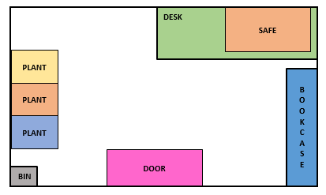

### Safe Design:

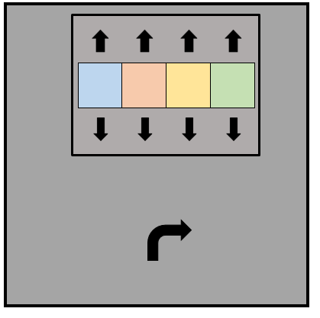

## Room 2: Loops

The room focuses on the player learning aspects of conditional scratch statements, which the user must then apply to unlock the final door to escape the space station. In this room, the player must use the console on the desk to move a pin along a maze and solve the maze.

### List of steps to complete the room:

1. The player will enter the room and familiarise themselves with the environment.
2. The objects in this room will not be used to solve the puzzle, they will have to solve a maze using the controls on the desk.
3. Once the maze has been solved it will reveal the piece of scratch code, via releasing it through a hidden side slot.

### Room Design:

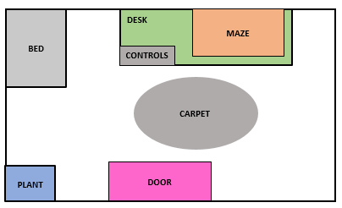

### Maze Design:

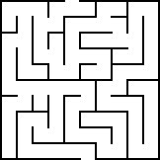

### Maze Solution:

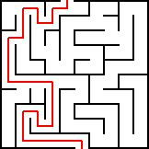

### Control Board:



### Scratch Code Given:

## Room 3: Sequence

The focus of this room is for the player to learn the place of sequencing in coding, teaching the player how code is ordered and for them to then be able to order the code in the right order to open the final door.

### List of steps to complete the room:

1. A

### Room Design:

### Scratch Code Given:

## Room 4: Event Handling

In terms of coding this would be when the user is prompted to input something or interact with the code in some way. Scratch teaches this through prompts such as “when a key is pressed” or “when the sprite is clicked” and we will use this to teach the user about how events / code can be triggered through these when they are coded into a program. And will be used towards the final block of code used to unlock the door.

### List of steps to complete the room:

1. A

### Room Design:

### Scratch Code Given:

# Research:

Room Design:

Coding:

<http://scratched.gse.harvard.edu/sites/default/files/scratchprogrammingconcepts-v14.pdf>

## Puzzles:

**Black light;**

Difficulty 1) have the player turn on the black light to reveal a hidden code or pattern.

Difficulty 2) have the player search for a cable to attach to the black light then to the plug, to reveal the hidden code or pattern.

Code Difficulty 1) have the code display a 4 digit number for the lock, e.g. 1234.

Code Difficulty 2) have a code disguised as a pattern of lines representing the digits.

Code Difficulty 3) have a full wall covered in symbols and numbers, e.g. certain colour code.

Pattern Difficulty 1) pattern is displayed when the light comes on, e.g. a rectangle.

Pattern Difficulty 2) have the pattern hidden in scrambled lines, solution is a particular colour.

**Hidden items;**

Difficulty 1) have key cards or playing cards with numbers on them hidden for the player to find, colour will indicate the order, colour will be shown on keypad, e.g. green box around first digit.

Difficulty 2)

Hiding places) in boxes / under carpet / coat / inside a book / draw / behind a plug.

**Maze:**

Difficulty 1) have the player drag a pin along a maze into the hole.

Difficulty 2) player has a time limit to solve the maze.

Difficulty 3) the maze will move as the player moves the pin along the hole.

**Puzzle solutions:**

Hidden code = safe / phone / computer / padlock.

Hidden pattern = phone / tablet.

## Clue:

Glow in the dark clue.

Morse code.

Pressure plate.

# Use Cases:

## 

## Use Case 1:

**Use Case:**

 Player interacts with the environment and familiarises themselves with controls.

**Primary Actor:**

 Player

**Secondary actors:**

Game

**Goal:**

For the player to feel comfortable manoeuvring around the game and interacting with objects and the puzzle.

**Preconditions:**

The game has launched successfully without any errors and the “Vive” headset and controllers are working and connected.

**Success End Condition:**

The player has is comfortable with the environment and controls and begins attempting to solve the puzzles.

**Failed End Condition:**

The game does not launch, the headset or controllers do not connect the player gets motion sickness.

**Trigger:**

The controller or headset is not detected.

**MAIN SUCCESS SCENARIO**

1. A

**EXTENSIONS**

<put here the extensions, one at a time, each referring to the relevant step of the main scenario>

<step altered><condition>:<action>

## Use Case 2:

**Use Case:**

**Primary Actor:**

**Secondary actors:**

**Goal:**

**Preconditions:**

**Success End Condition:**

**Failed End Condition:**

**Trigger:**

**MAIN SUCCESS SCENARIO**

1. A

**EXTENSIONS**

<put here the extensions, one at a time, each referring to the relevant step of the main scenario>

<step altered><condition>:<action>

## Use Case 3:

**Use Case:**

**Primary Actor:**

**Secondary actors:**

**Goal:**

**Preconditions:**

**Success End Condition:**

**Failed End Condition:**

**Trigger:**

**MAIN SUCCESS SCENARIO**

1. A

**EXTENSIONS**

<put here the extensions, one at a time, each referring to the relevant step of the main scenario>

<step altered><condition>:<action>

# Use Case Modelling:

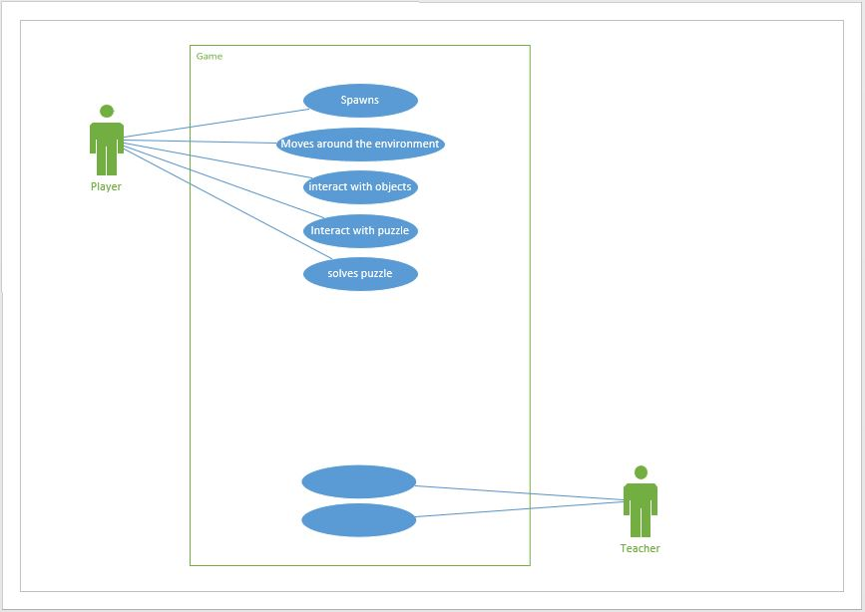

# Time Frame:

## Project Plan timeline:

|  |  |  |
| --- | --- | --- |
| **Goal** | **Deadline Date** | **Person Responsible for development** |
| Puzzle room 1 research | 13th March | John & Ross |
| Room 1 layout & textures | 13th March | Jack & James |
| Room 1 puzzle implemented | 20th March | John & James |
| Testing Room 1 | 21st March | Everyone |
| Puzzle room 2 research | 21st March |  |
| Room 2 layout & textures | 27th March |  |
| Room 2 puzzle implemented | 27th March |  |
| Testing Room 2 | 27th March |  |
| Puzzle room 3 research | 3rd April |  |
| Room 3layout & textures | 3rd April |  |
| Room 3 puzzle implemented | 3rd April |  |
| Testing Room 3 | 3rd April |  |
| Puzzle room 4 research | 10th April |  |
| Room 4 layout & textures | 17th April |  |
| Room 4 puzzle implemented | 24th April |  |
| Testing Room 4 | 24th April |  |
| Tutorial layout & textures | 1st May |  |
| Tutorial room testing | 8th May |  |
| Submission Date | 13th May | Susan |

# Challenges:

Ross:

### Challenges encountered:

## Jack:

### Challenges encountered:

## James:

### Challenges encountered:

* Making sure that objects were not too big or too small in VR as the room appears much bigger with the headset on
* Had issues with the animations on the doors to work at the correct time
  + Had to do lots of testing with different lengths from the door to ensure that the door opened when we wanted.
* Making sure that none of the walls were overlapping as this caused a strange flashing effect
* Deciding what to keep and what to get rid of from our original idea to ensure we finished on time

## John:

### Challenges encountered:

# Evidence / Screenshots of Progress:

## Original Pitch:

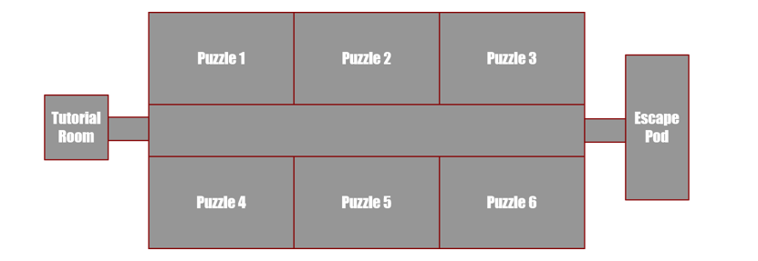

## Game first design with textures:

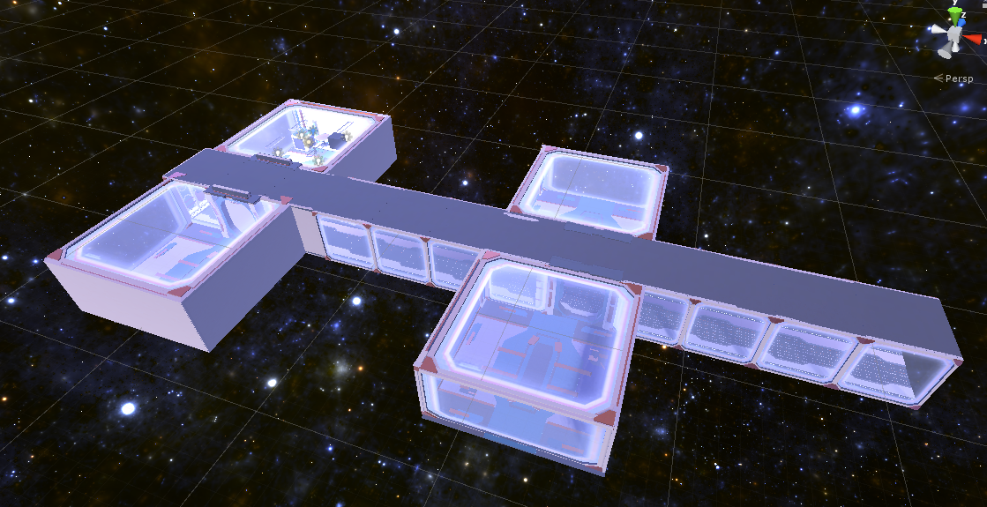

## Game stage 1:

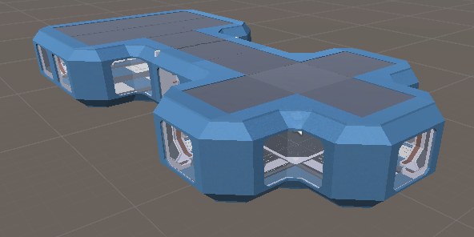

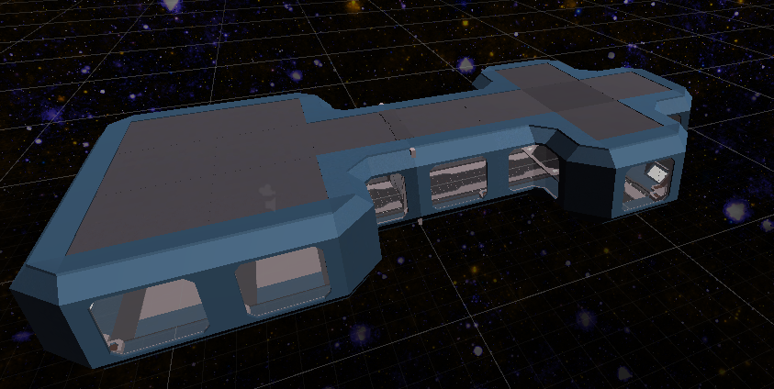

## Game interior:

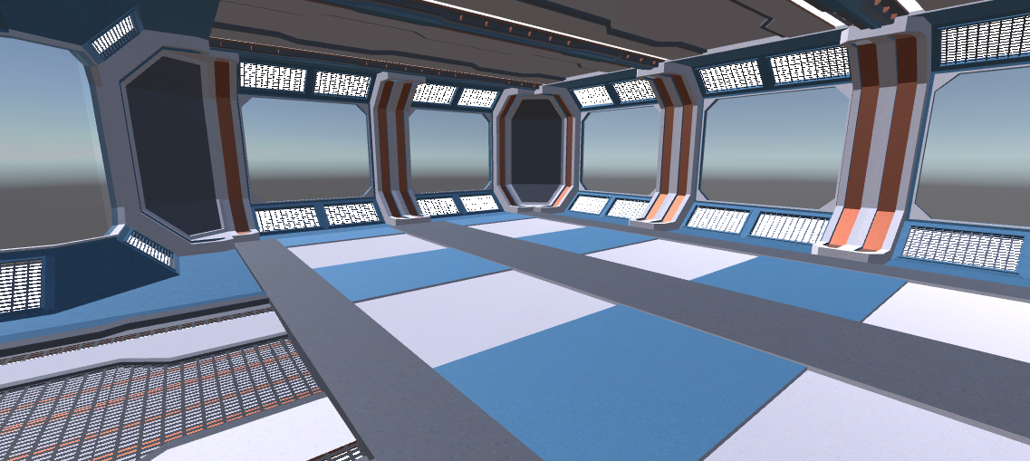

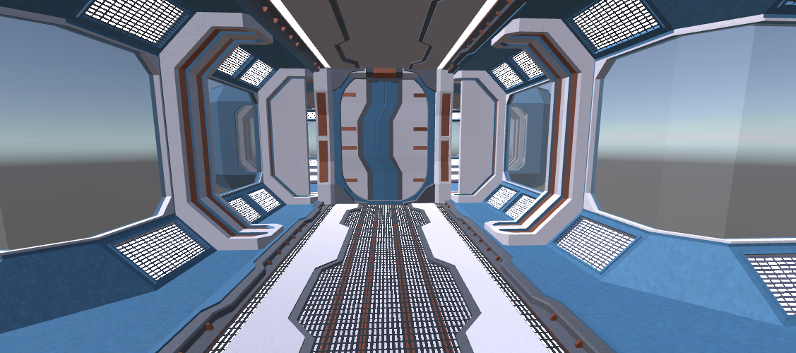

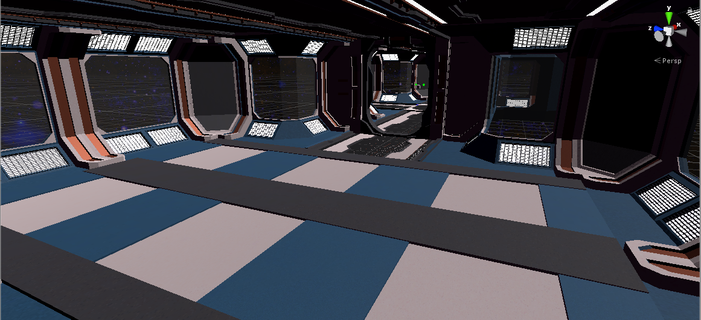

## Interaction with objects:

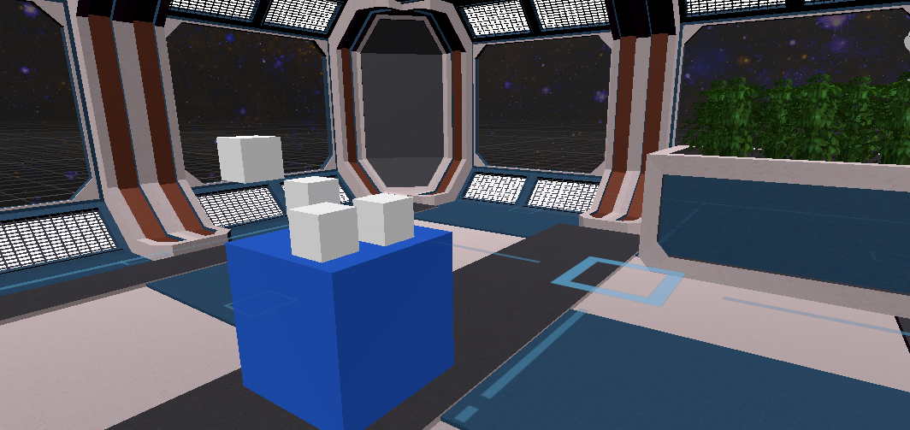

## Final Game Screenshots

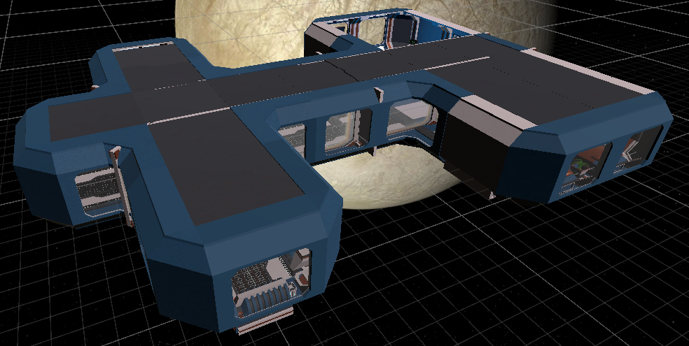

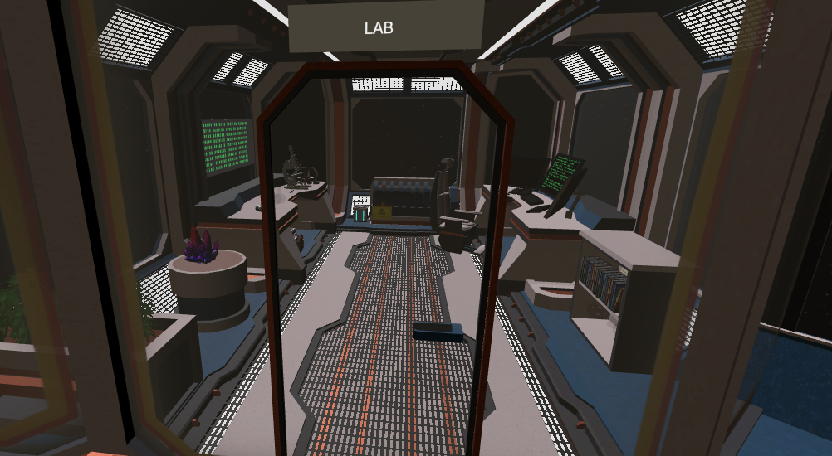

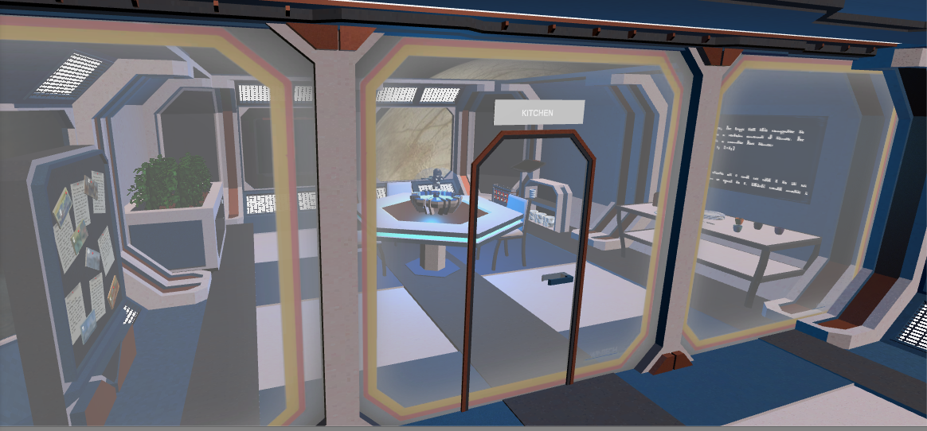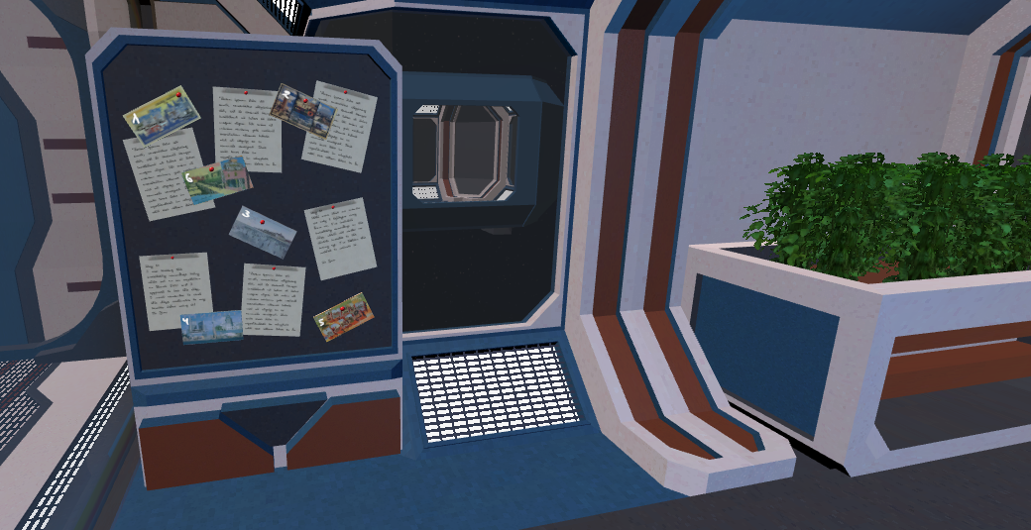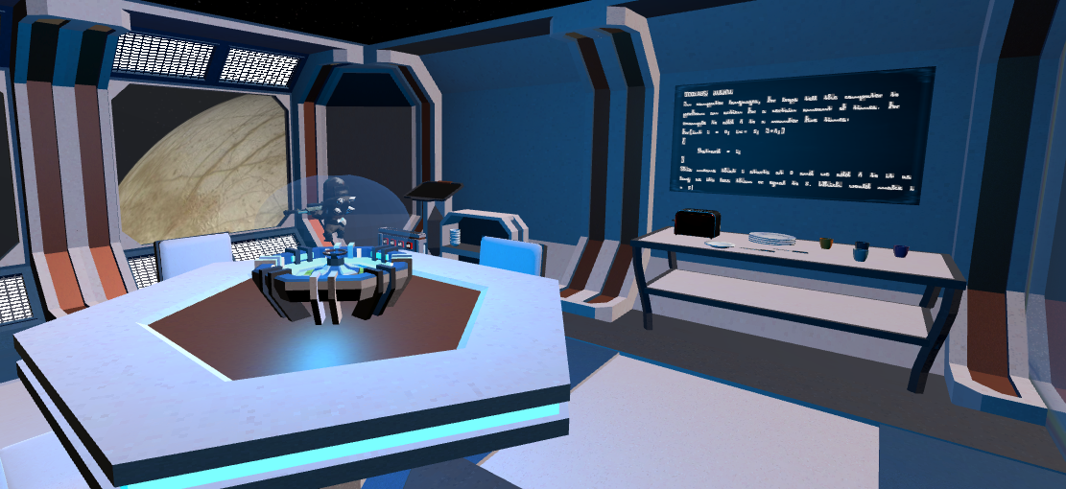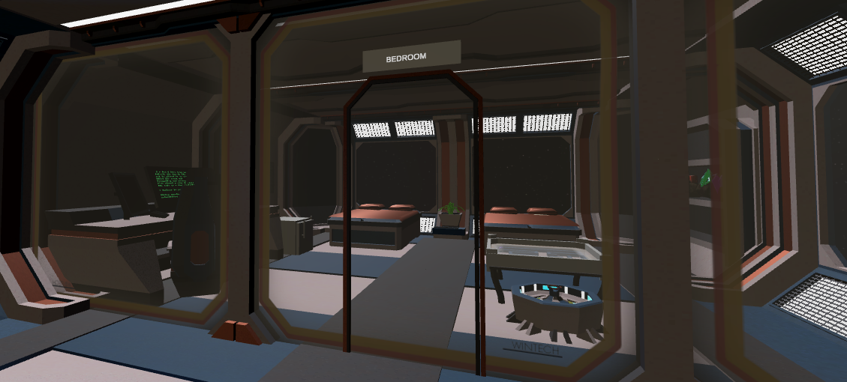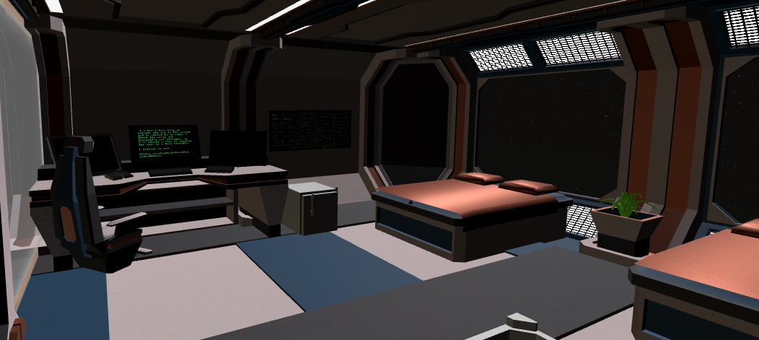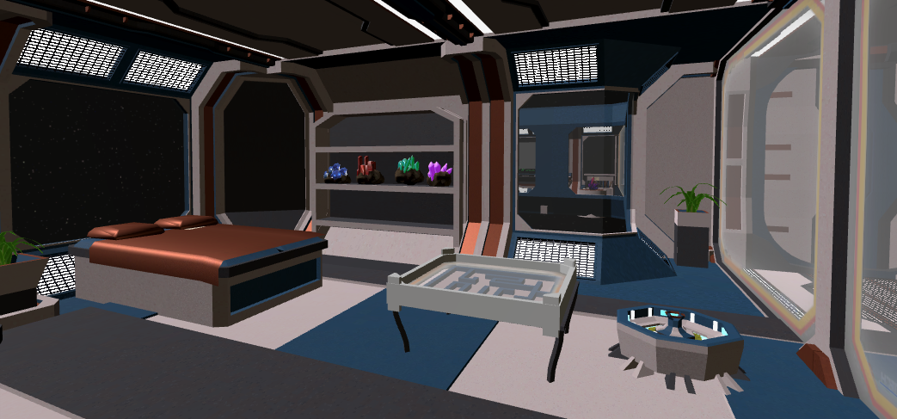

## Blender:

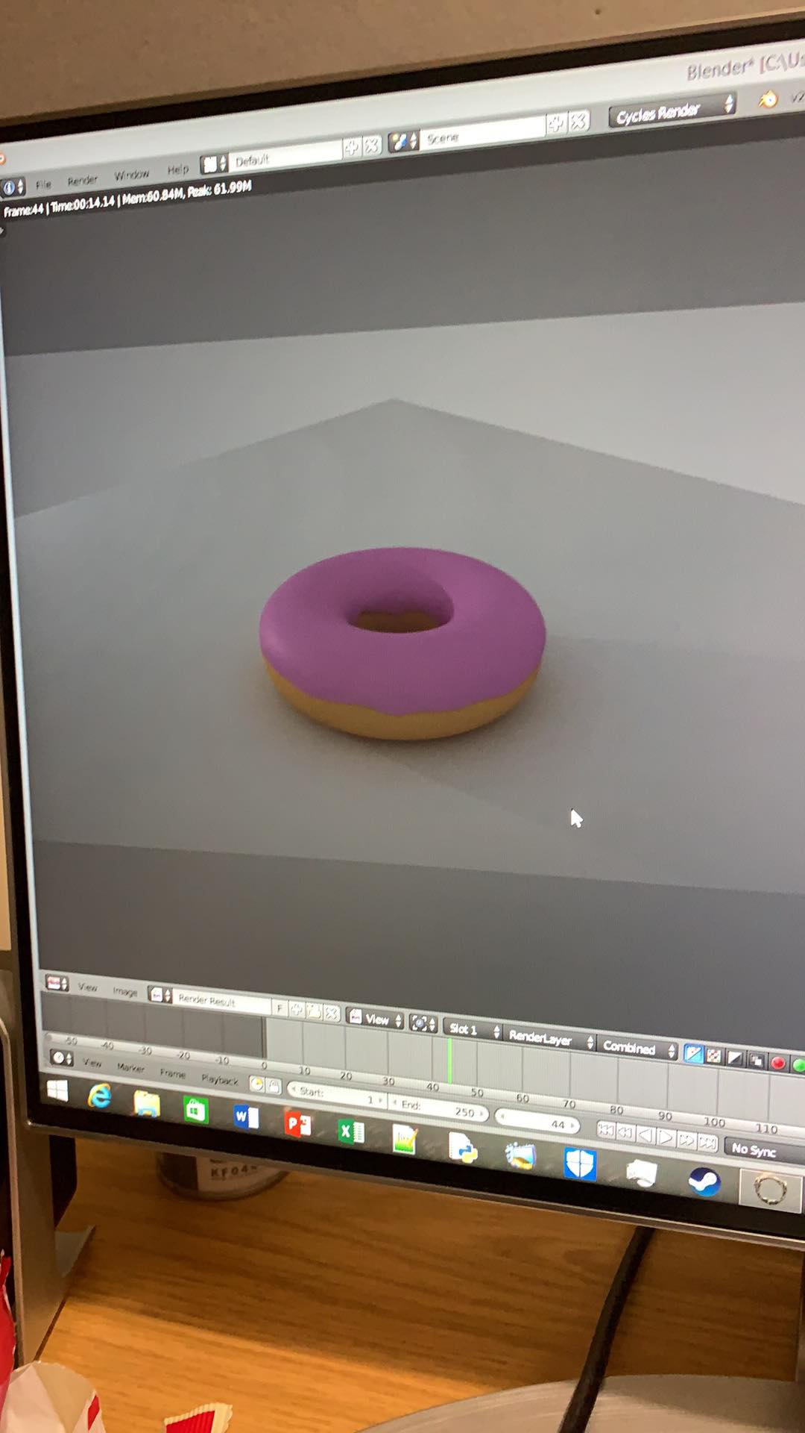

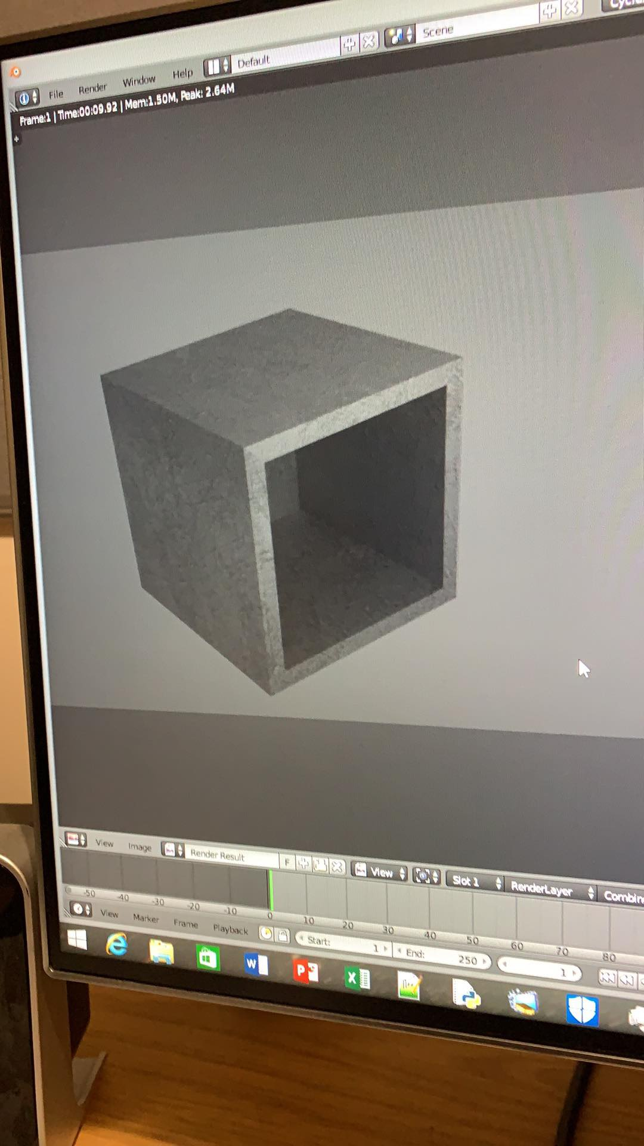

# References:

**Assignment brief:**

<https://studentcentral.brighton.ac.uk/webapps/blackboard/execute/content/blankPage?cmd=view&content_id=_3335048_1&course_id=_110301_1>

**Puzzle ideas:**

<https://escaperoomtips.com/design/escape-room-puzzle-ideas>

<http://www.queencityescape.com/top-20-puzzle-ideas/>

**Scratch:**

<https://scratch.mit.edu/projects/editor/?tutorial=getStarted>

<http://scratched.gse.harvard.edu/sites/default/files/scratchprogrammingconcepts-v14.pdf>

**Maze:**

<http://www.mazegenerator.net/>